**SAE BAJA**

**YEAR: 2012**

In **January2012**, our college team **ALPHOENIX** participated in the final round of BAJA 2012 held at Pithampur, Indore.

The main objective of the BAJA is to bring out the creative and innovative ideas of the students. Each team’s goal is to design and build a prototype of a rugged, single seat, all-terrain vehicle intended for sale to the non‐professional weekend off‐road enthusiast.

**BAJA DESIGN**

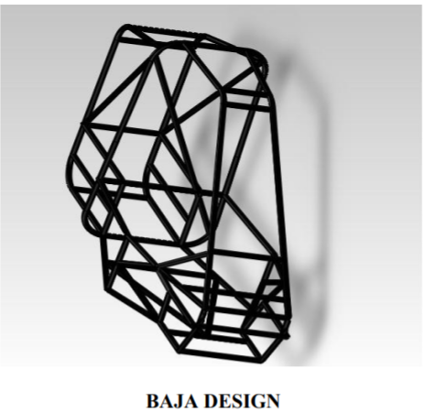

**YEAR: 2017**

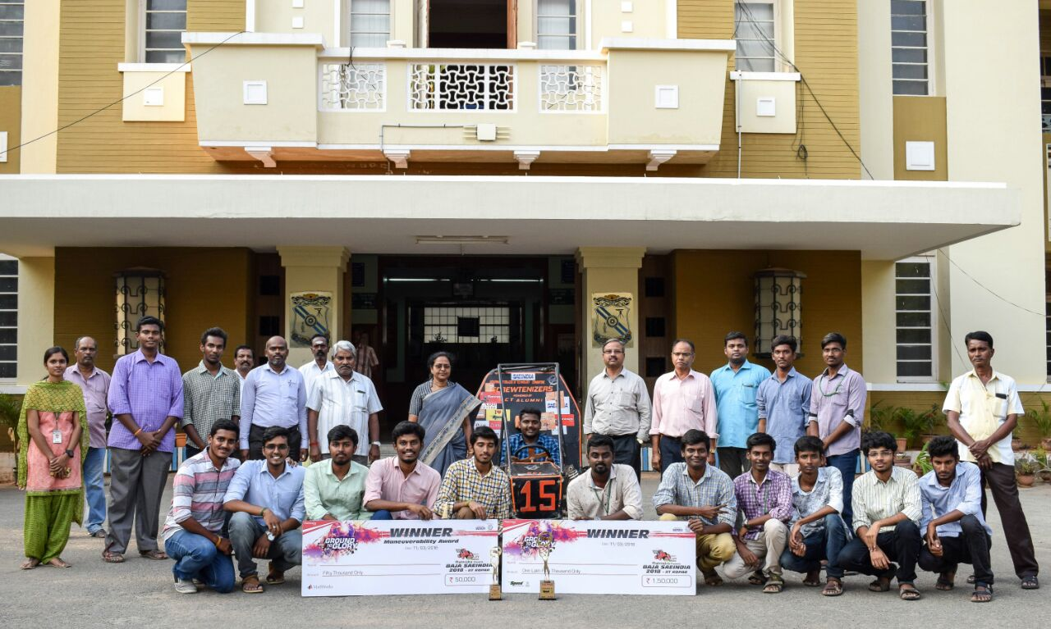**TEAM SCREWTENIZERS**

After 5 years of constant hard work, determination and untiring efforts the collegiate club of GCT made a remarkable achievement in **SAEINDIA BAJA**, ALL INDIA **ENGINEERING DESIGN CHALLENGE COMPETITION**where team **“SCREWTENIZERS”**made the history after 2012 securing the **OVERALL WINNERS – IIT ROPAR**, PUNJAB**.**

Not only this, the team made a legacy by winning in the first season of BAJA which was held at IIT Ropar, Punjab. The following are team’s achievements in this season bagging 4 awards.

* **Manuverability – 1st**
* **Endurance – 2nd**
* **Design Evaluation – 2nd**
* **Sales Presentation – 2nd**
* **Cost Evaluation – 2nd**
* **Sledge Pull – 3rd**

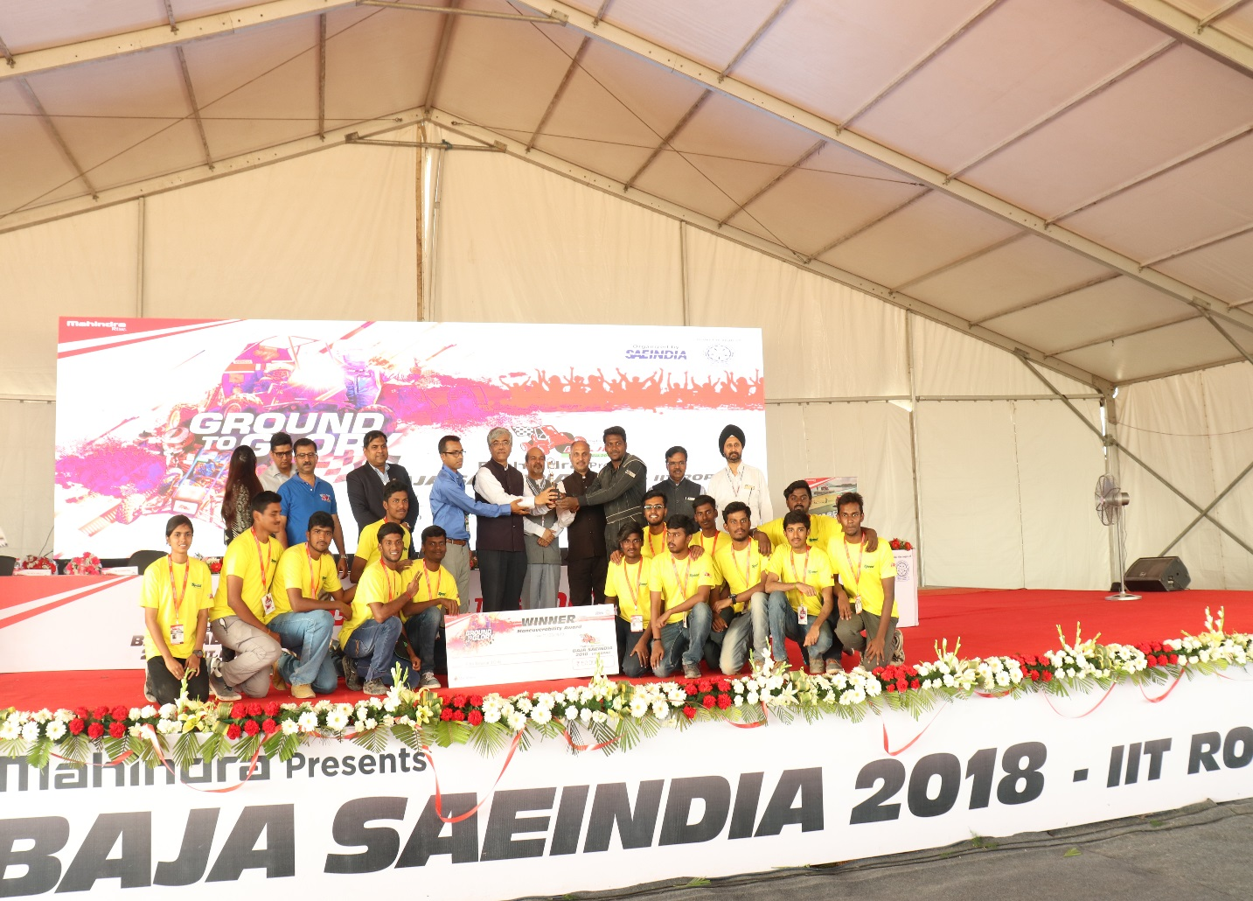

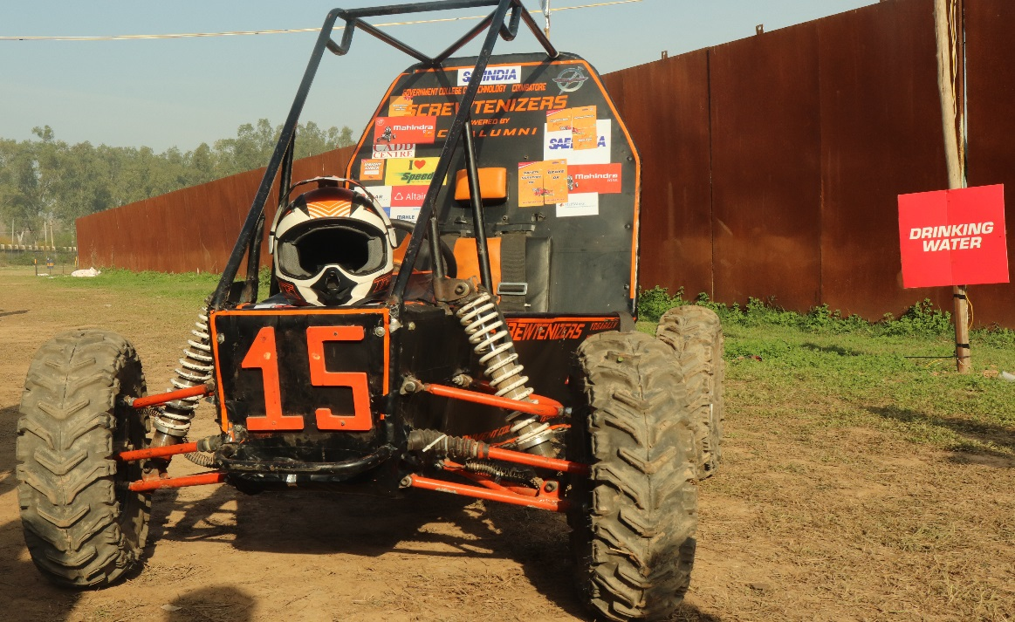

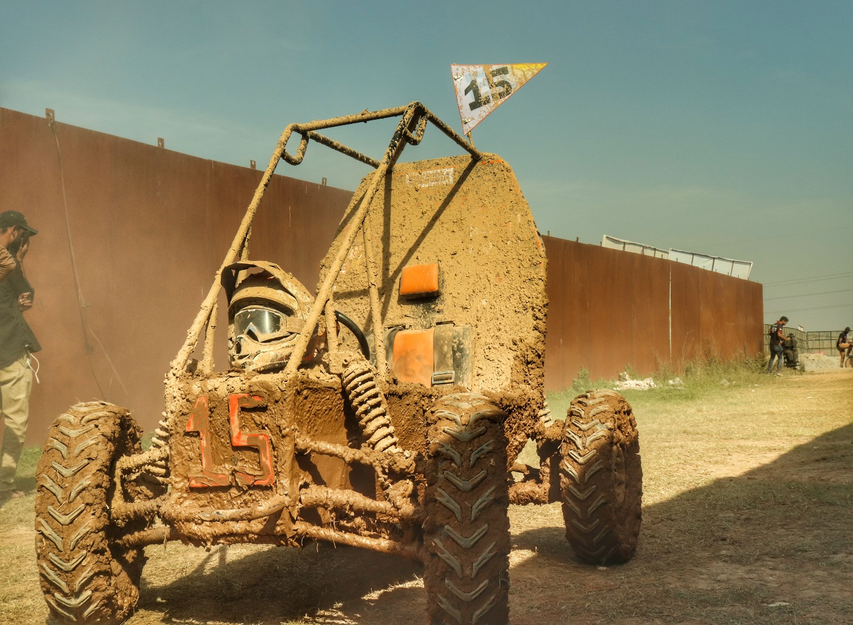

**ACHIEVEMENTS:**

We have been constantly participating in the SAE BAJA event continuously and placed at significant places in those events.

|  |  |  |
| --- | --- | --- |
| 1 | BAJA SAE 2018  (All-Terrain Vehicle Design Challenge) | Overall 1st  Maneuverability – 1st  Endurance – 2nd  Design Evaluation – 2nd  Sales Presentation – 2nd  Cost Evaluation – 2nd  Sled Pull – 3rd |
| 2 | BAJA SAE INDIA 2019  (All-Terrain Vehicle Design Challenge) | Cost Event -2nd  Design Event - 18th  Sales Presentation -13st  Endurance - 9th |
| 3 | BAJA SAE INDIA 2020  (All-Terrain Vehicle Design Challenge) | Cost Event- 4th  Design Event - 46th  Sales Presentation - 71st |
| 4 | BAJA SAE INTERNATIONAL ARIZONA 2020  (All-Terrain Vehicle Design Challenge) | Cost Event - 8th  Design Event -21st  Sales Presentation - 27th |
| 5 | BAJA SAE INTERNATIONAL  ARIZONA 2021  (All-Terrain Vehicle Design Challenge) | Overall – 34th  Design – 40th  Cost - 20th |

**SAE INDIA 2019**:

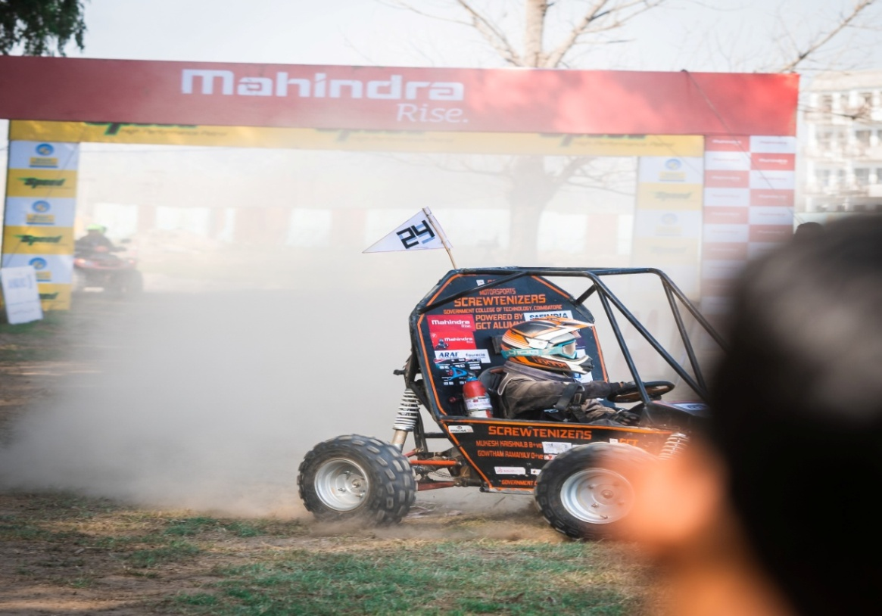

**BAJA ARIZONA PARTICIPATION 2021:**

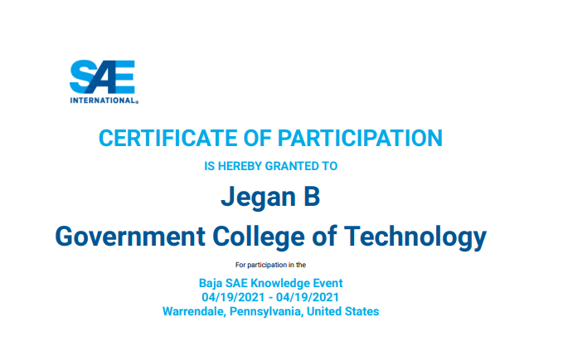

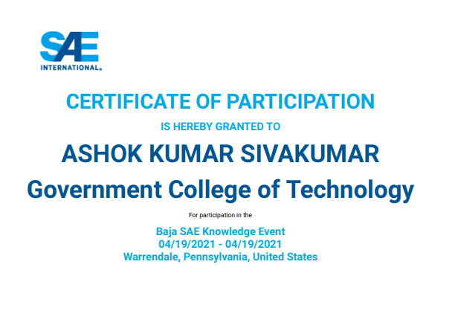

**POST EVENT RANKINGS IN SAE INDIA ONLINE:**

