**TRACTOR DESIGN COMPETITION 2018:**

Another big series of achievement is that our hard work and determination paved way for the success in the fresh season of new event organized by Southern Section of SAE as **“TDC – a Tractor Design Competition”.** The team **“ASPHALTERS”**secured **OVERALL WINNERS – SRM UNIVERSITY, CHENNAI.**

* BEST TRACTOR DESIGN – 1ST
* 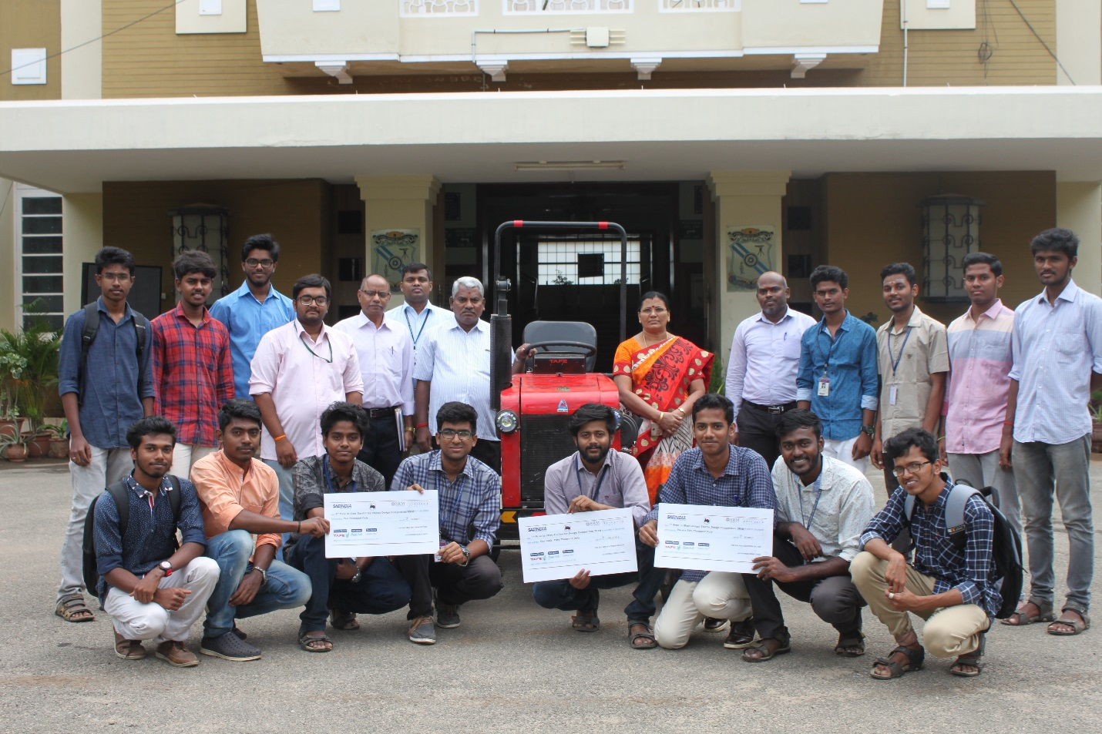DURABILITY – 3RD

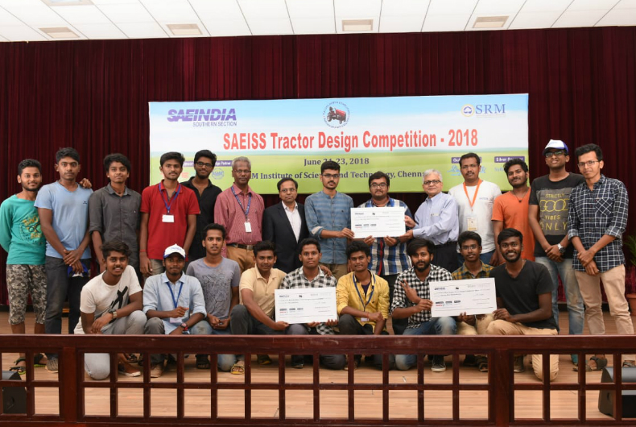

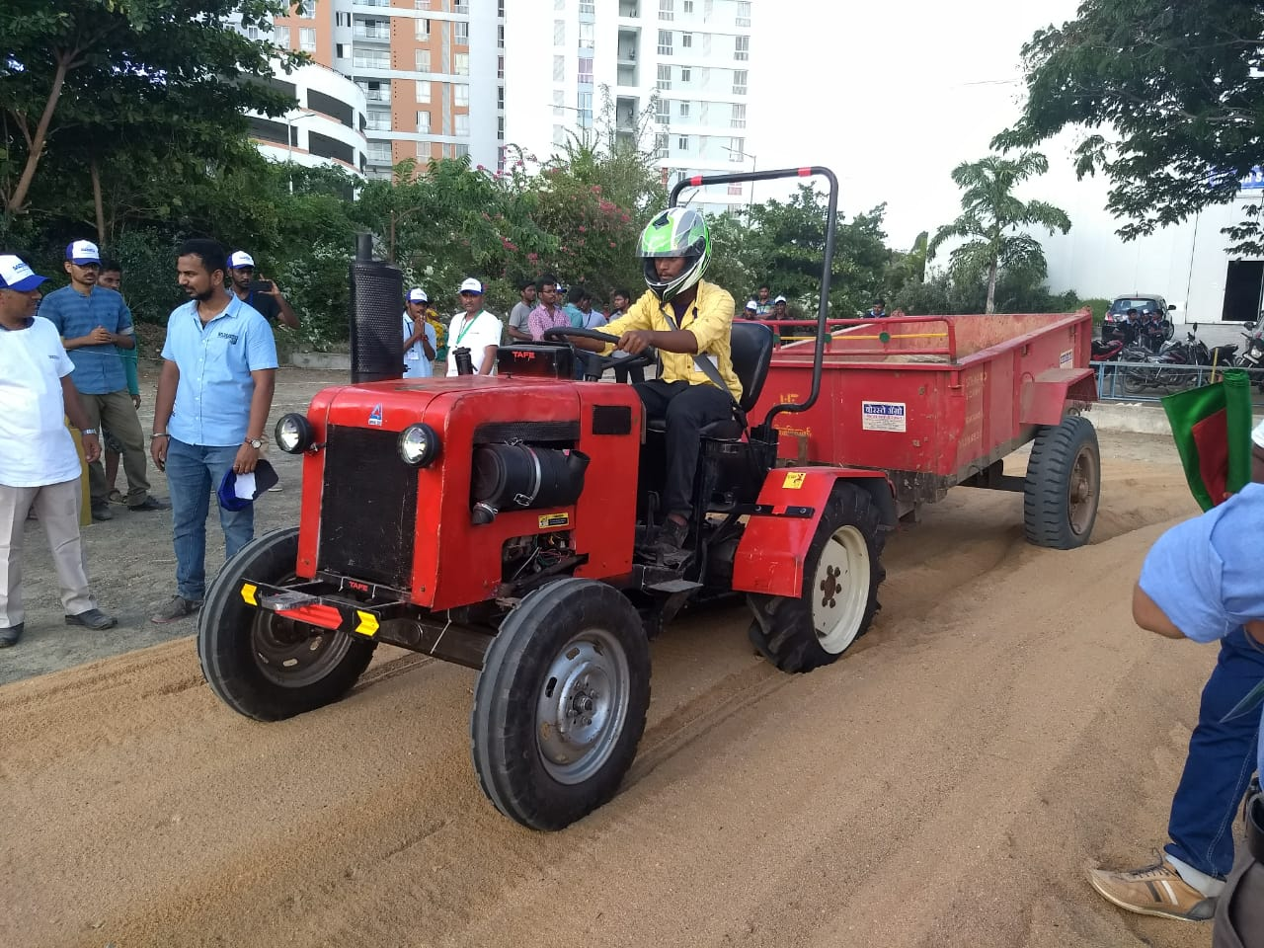

**TDC 2019:**

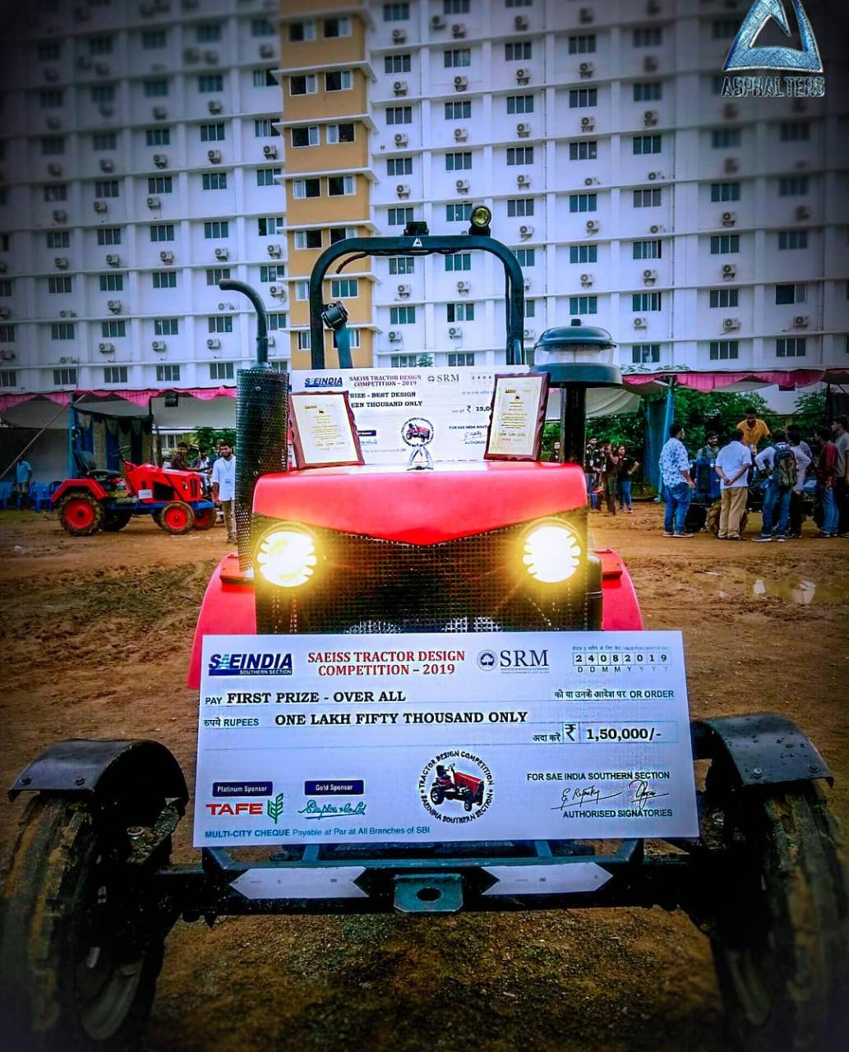

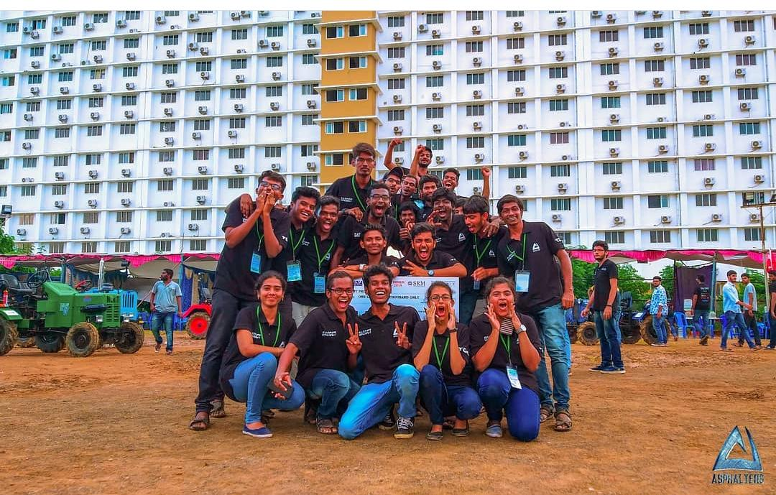

**TDC 2020 (ONLINE):**

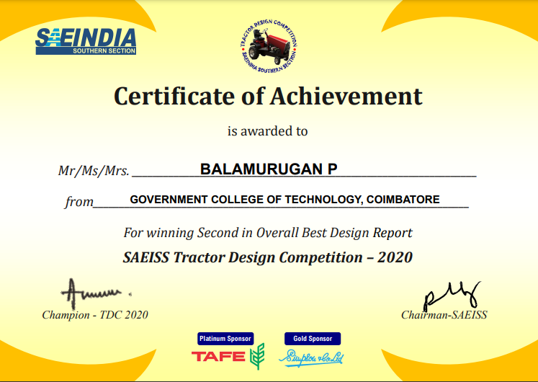

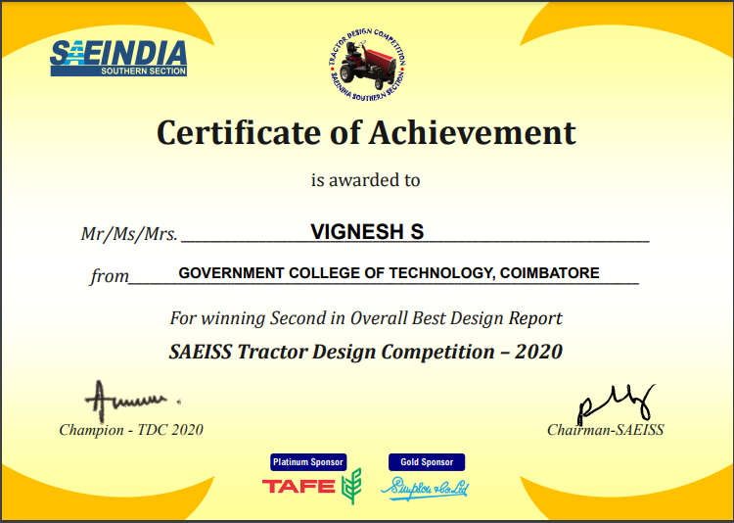

**ACHIEVEMENTS:**

|  |  |  |
| --- | --- | --- |
| 1 | TDC 2018  (Tractor Design Challenge) | Overall -1st  Durability - 3rd |
| 2 | TDC 2019  (Tractor Design Challenge) | Overall - 1st  Best Design - 2nd |
| 3 | TDC 2020  (Tractor Design Challenge) | Overall - 2nd  Best Design - 2nd  Best design approach - 5th |